**Assignment Day 4**

1. List all customers and the products they ordered with the order date. (Inner join)

**Tables used:** customers, orders, order_details, products

**Output should have below columns:**

companyname AS customer,

orderid,

productname,

quantity,

orderdate

select c.company_name AS customer,o.order_id,o.order_date,

od.product_id,

p.product_name,p.quantity_per_unit

from customers c

Inner Join orders o ON c.customer_id = o.customer_id

inner join order_details od ON o.order_id = od.order_id

inner join products p ON p.product_id = od.product_id

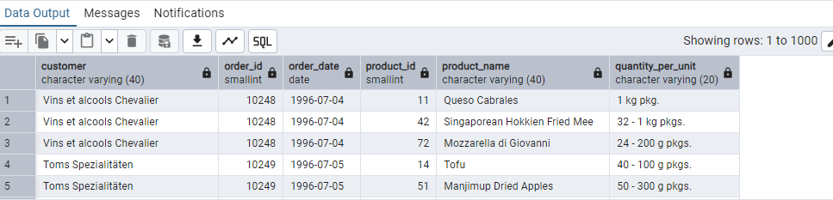

2. Show each order with customer, employee, shipper, and product info — even if some parts are missing. (Left Join)

**Tables used: orders, customers, employees, shippers, order_details, products**

select

o.order_id,

c.company_name as customer,

e.first_name || ' ' || e.last_name as employee,

s.company_name as shipper,

p.product_name,

od.quantity

from orders o

left join customers c on o.customer_id = c.customer_id

left join employees e on o.employee_id = e.employee_id

left join shippers s on o.ship_via = s.shipper_id

left join order_details od on o.order_id = od.order_id

left join products p on od.product_id = p.product_id

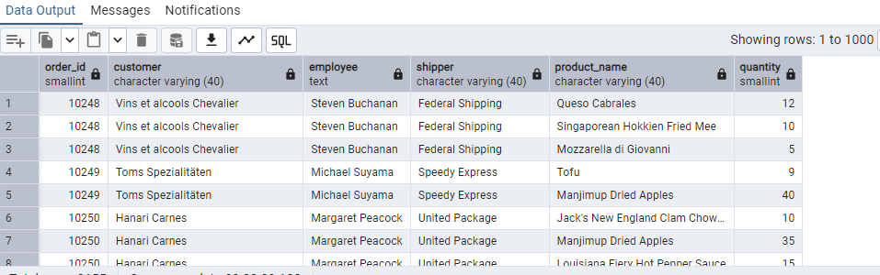

3. Show all order details and products (include all products even if they were never ordered). (Right Join)

**Tables used: order_details, products**

**Output should have below columns:**

orderid,

productid,

quantity,

productname

select

od.order_id,

od.product_id,

p.product_name, p.quantity_per_unit

from order_details od

right join products p ON od.product_id = p.product_id

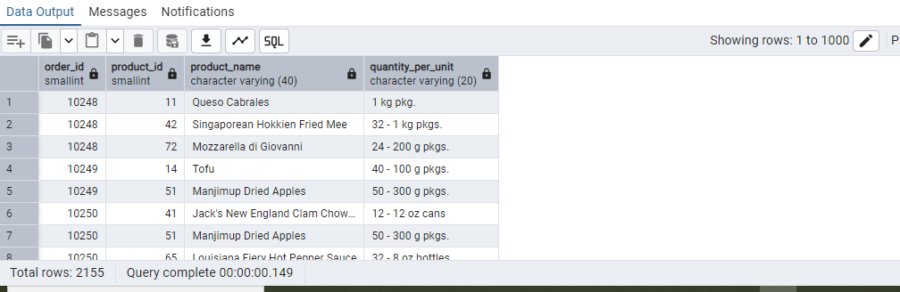

4. List all product categories and their products — including categories that have no products, and products that are not assigned to any category.(Outer Join)

**Tables used: categories, products**

select p.product_name,c.category_name

from products p

Full Outer Join categories c on p.category_id = c.category_id

5. Show all possible product and category combinations (Cross join).

select p.product_name,c.category_name

from products p

Cross Join categories c

6. Show all employees and their manager(Self join(left join))

select e1.first_name ||' '||e1.last_name as manager_name,

e2.first_name ||' '||e2.last_name as employee_name

from employees e1

left Join employees e2 on e2.reports_to = e1.employee_id

7. List all customers who have not selected a shipping method.

**Tables used:** customers, orders

**(Left Join, WHERE o.shipvia IS NULL)**

